Project Report
Guidelines
Bachelor of Computer Applications (BCA)
Program



Centre for Distance & Online Education
Manipal University Jaipur
Dehmi Kalan, Rajasthan – 303 007.

Contents
Contents
2.1 Phase 2: Project Work 2
2.1.1 Components of Project Report 3
2.2 Project Evaluation 4
2.4 Project Viva Voce / Presentation 5

2.1 Phase 2: Project Work

Project Report and Viva-Voce process

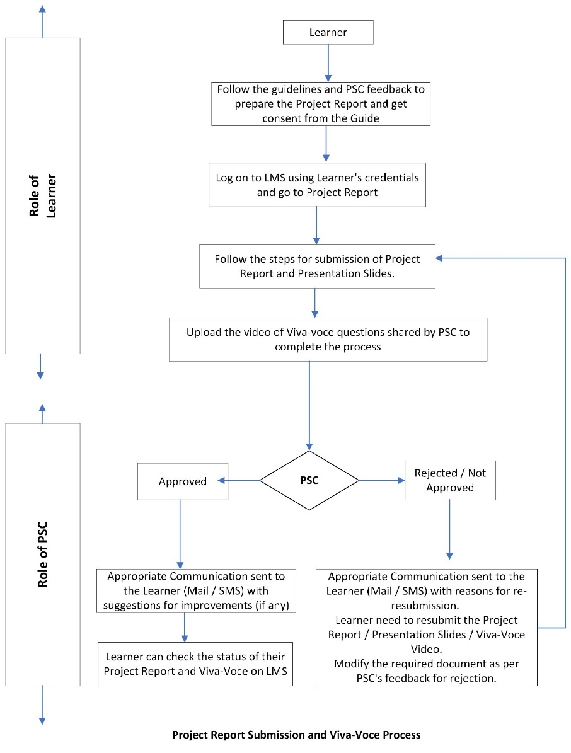
As project work is an important part of the - BCA course curriculum, it has been marked 24 credits. The following guidelines need to be followed for BCA projects.
  - The project must be a live project either done at the place of work or some other organization.
  - The project must be related to the specialization pursued.
  - The title selected should be coherent with the stream of study or specialization.
  - The learner and the guide have the freedom to identify an appropriate topic.
  - The project title should be specific and focused towards the objectives of the project.
  - Project work should be undertaken on the same topic that has been approved by PSC.

2.1.1 Components of Project Report
These guidelines will provide the information for developing a project report. The components of the Project Report expected from the learners may include the following:
- Table of Contents
- Introduction/Objectives
- System Analysis
  - Identification Of Need
  - Preliminary Investigation
  - Feasibility Study
  - Project Planning
  - Project Scheduling (PERT Chart & Gantt Chart)
- Software Requirement Specifications (SRS)
  - Software Engineering Paradigm applied.
  - Data Models (like DFD)/Control Flow Diagrams/State Diagrams/Sequence Diagrams/ Entity Relationship Models, Class Diagrams/CRC Models/ Collaboration Diagrams/Use-case Diagrams/Activity Diagrams depending upon your project requirements.
- System Design
  - Modularisation Details
  - Data Integrity and Constraints
  - Database Design, Procedural Design/Object Oriented Design
  - User Interface Design
  - Test Cases (Unit Test Cases and System Test Cases)
- Coding
  - SQL commands for
    - Database Creation (along with constraints)
    - Data Insertion in Tables, and
    - Access Rights for different users
  - Standardization of the coding
  - Code Efficiency
  - Error Handling
  - Parameters Calling/Passing
  - Validation Checks
- Testing
  - Testing Techniques and Testing Strategies used.
  - Testing Plan Used
  - Test reports for Unit Test Cases & System Test Cases
  - Debugging and Code Improvement
- System Security Measures
  - Database/Data Security implementation
  - Creation of User Profiles
  - Managing the User Rights
- Cost Estimation and its Model
- Future Scope
- Bibliography
- Appendices (if any)
- Data Dictionary

2.2 Project Evaluation
Evaluation Pattern for the project is based on the following categories:
- Synopsis (30% - Internal Assessment (IA)),
- Project report and viva voce (70% - Term-End-Examination (TEE)).
Project Steering Committee (PSC) will evaluate the submitted synopsis and the marks will be awarded as per the distribution given below:

Section | File/Document | Marks
Section – A (Internal Assessment) | Project Synopsis (under Sem 3 tab), post guide approval | 30
Section – A (Term End) | Project Report | 50
Section – B (Term End) | Answer for Viva Questions | 20
TOTAL |  | 100

2.4 Project Viva Voce / Presentation
The presentation along with a 3 -5-minute video showing the project execution should be uploaded on LMS within the timeline stipulated by the University. Viva will be conducted as per the schedule given by the Office of Learner Evaluation. The project work is completed with the viva voce / presentation.

